Test Case 1 : Source Query :

Select 'png_mdsdb.pg_ot_processing_activities_inventory_final' ,Count(1) as CNT

FROM png_mdsdb.pg_ot_processing_activities_inventory_final a where a.cdctype='X'

group by 1

UNION

SELECT 'd_png_ot_processing_activities_inventory_c',Count(1) as CNT

FROM png_mdwdb.d_png_ot_processing_activities_inventory_c b where b.soft_deleted_flag='N'

group by 1

UNION

SELECT 'd_png_ot_processing_activities_inventory_c',Count(1) as CNT

FROM png_mdwdb.f_png_ot_processing_activities_inventory_c b where b.soft_deleted_flag='N'

group by 1;

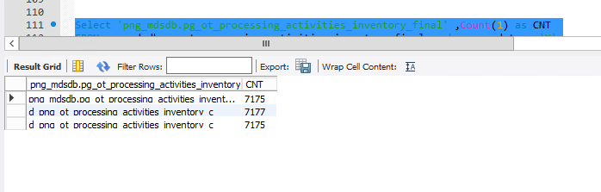

Test Case 2: Cube filter :

select

count(a11.row_key) Row_Count

from ldb.f_png_ot_processing_activities_inventory_c a11

JOIN ldb.d_processing_activities_managing_organization_c d ON a11.managing_organization_c_key=d.row_key

Where d.organization_name NOT IN ('999-Temporary Test')

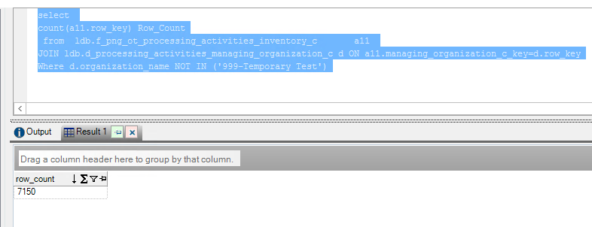

Test case 3: Cube Query : No Drops in both Cubes Rita_inventory_c and Rita_processing_activites_c cube

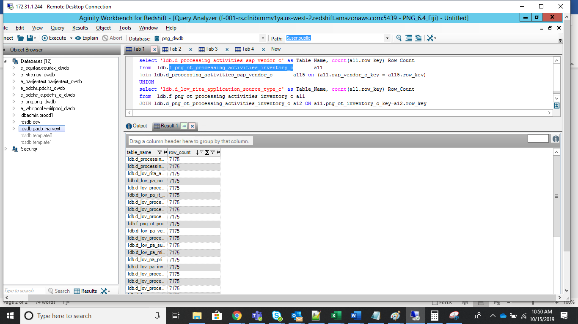

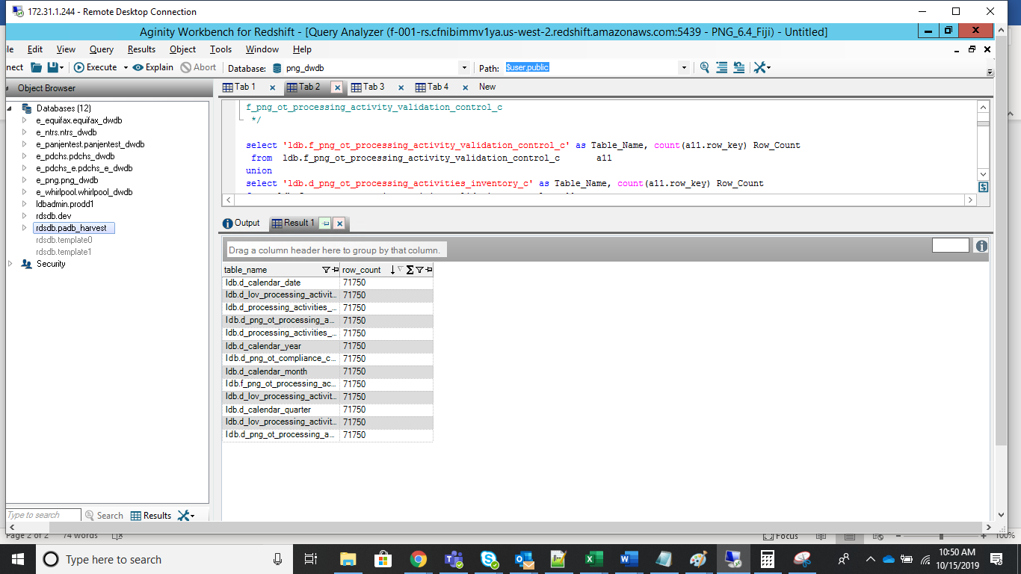

Dashboard validation : Compliance Cockpit

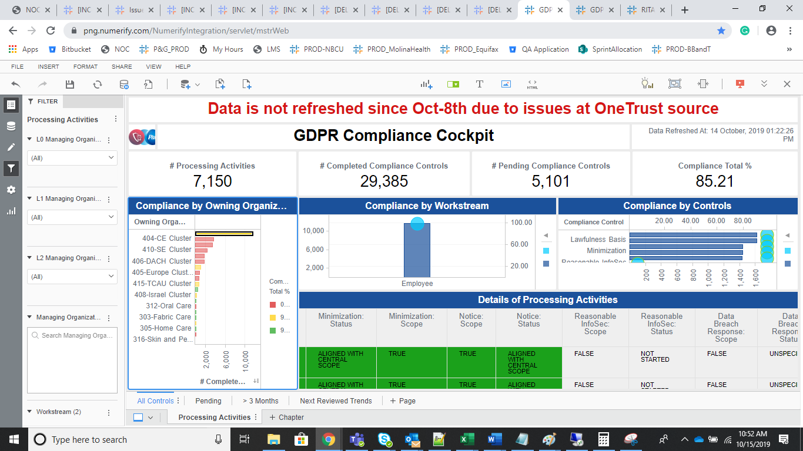 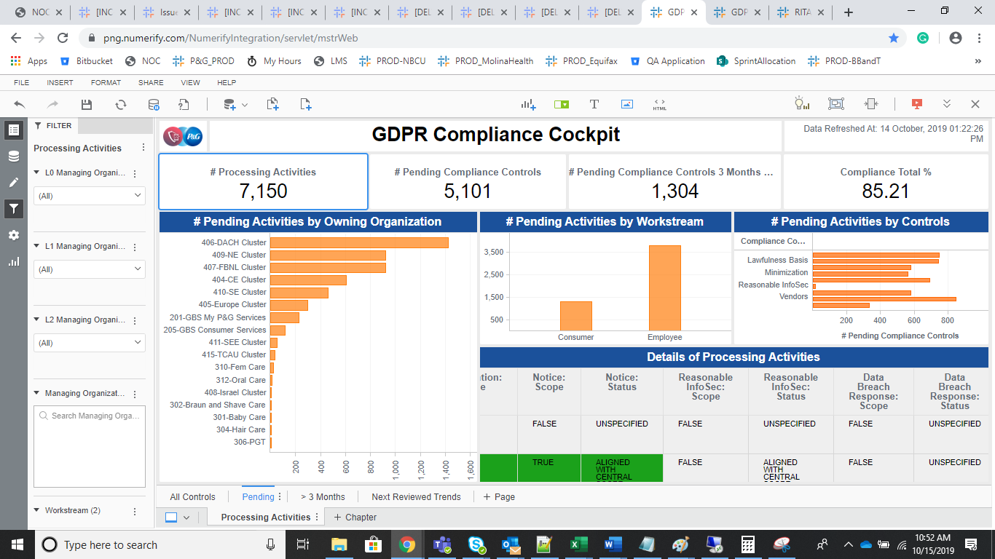

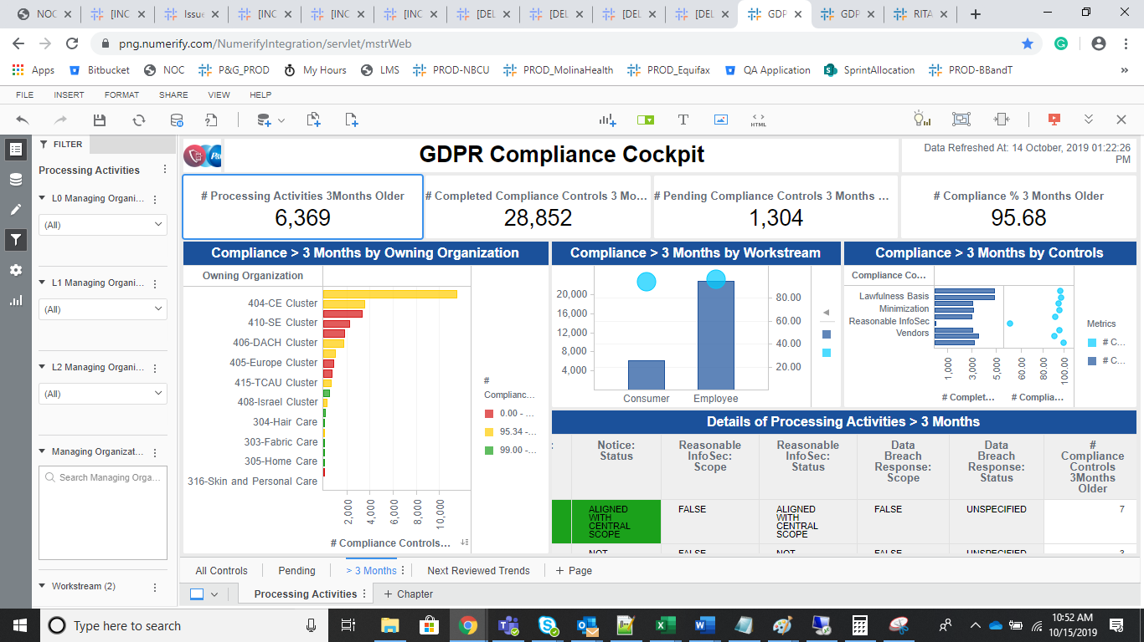

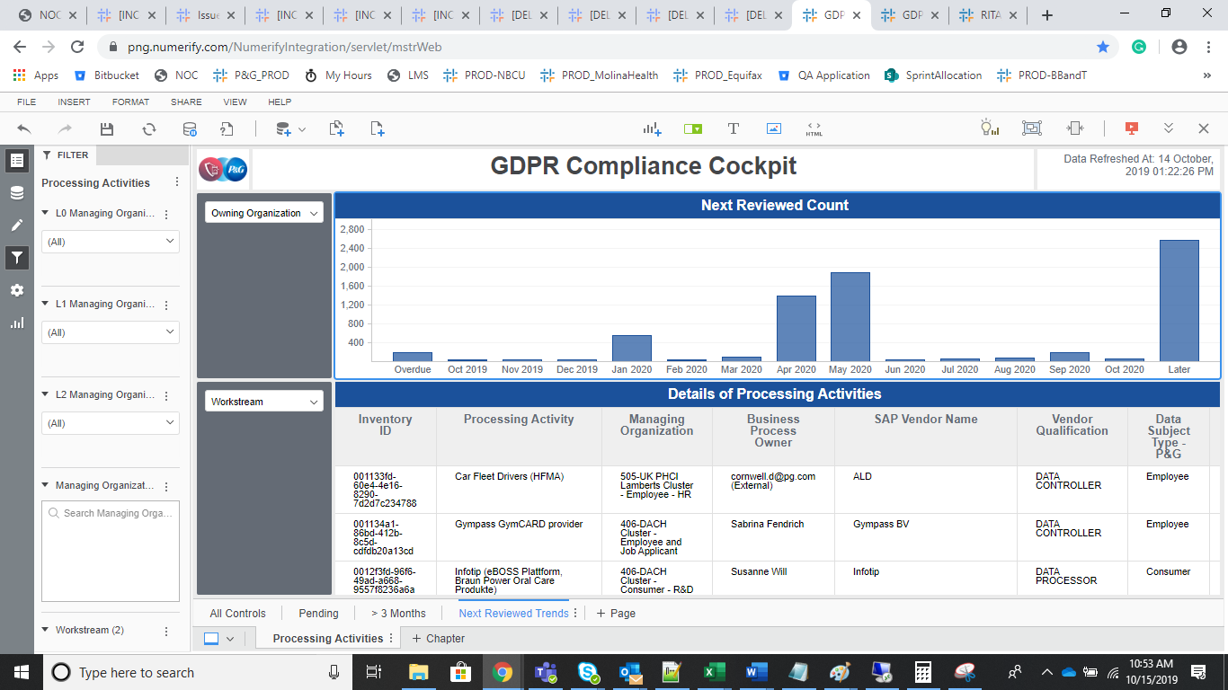

GDPR Dashboard :

